Maths Intervention Report
School Year: 7
Student: Freddie Smith
This standard report format can be used by schools to report on individual student’s progress within maths intervention at the end of the school year.
Most text (black font) is standard, with the data available to copy from the Student Tracking Portal, making this a quick report to produce whilst not compromising on content and information for parents.

Date of Report: 1st July 2025

Start of Intervention: November 2024 (2 lessons per week)

Date of baseline assessment : October 2024

Summary

The Maths Intervention Programme from the School Consultancy Programme supports the catch-up progress of students who have gaps in their primary maths understanding. After a detailed and thorough assessment of where the student is working, we follow a plan of action across 20 areas of maths to work with the student to close these gaps to work towards students feeling more confident and meeting age expectation in maths. [Standard text]

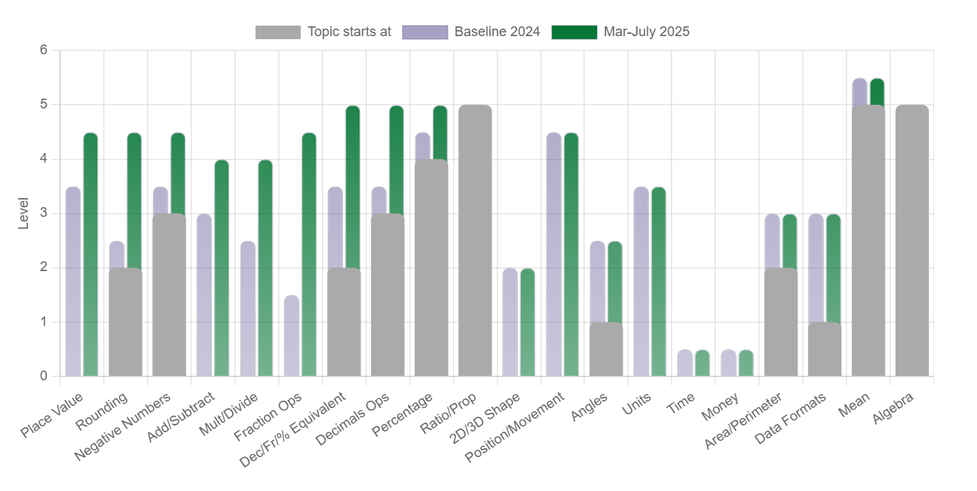
[This progress data is available to copy across from Student Tracking Portal for each student]

Explanation: [Standard text]

The intervention covers 20 main topic areas of maths. Within each area, there are two bars:
- the blue/grey bar representing your child’s starting level of achievement (their ‘baseline’ from their assessment)
- the green bar representing their current level.
The solid grey bars represent a topic not taught until a certain level (e.g. rounding is taught from Level 3 onwards).

During Maths Intervention, we initially focus on the ‘number’ side of maths, covering the first 10 areas, as these are the most significant cumulative areas for holding up student progress in secondary maths.

Progress in maths: [Available from the progress data above]
Topic Area – ‘Number’ Maths Areas | Progress (in years) | Topic Area – Wider Maths Areas | Progress (in years)
Place Value | +1 year | 2D/3D Shape | N/A
Rounding | +2 years | Position/Movement | N/A
Negative Numbers | +1 year | Angles | N/A
Add/Subtract | +1 year | Units | N/A
Multiply/Divide | +1.5 years | Time | N/A
Fraction Operations | +3 years | Money | N/A
Decimal, Fraction, % equivalents | +1.5 years | Area/Perimeter | N/A
Decimal Operations | +1.5 years | Data Formats | N/A
Percentages | +0.5 years | Mean | N/A
Ratio/Proportion | N/A | Algebra | N/A

Comments:
Freddie is always on time for his intervention lessons and approaches his work with enthusiasm and independence. He will, however, always ask for help when needed and listens well to explanations. He always tries his best and particularly enjoys the end of topic assessments and seeing how much he can do on his own. He is a visual learner and uses pictures and diagrams to support his understanding. [Comment from intervention lead]

Next Steps:
Continue with the maths intervention until gaps are closed to Level 6, focusing first on the number side of maths before picking up on the wider maths areas. [Comment from intervention lead – can be left relatively generic]

Student Voice:
‘I like the maths intervention lessons because it has helped me understand things I couldn’t do before and feel more confident in my main maths lessons too.’ [Student’s comment]

Report produced by ____________________________________
(Intervention Lead)

If a student has been included in Maths Intervention for longer than this academic year, you may want to also show the progress overall from baseline tracking. This table could be used as an alternative to the above:
‘Number’ Maths Areas | Progress (in years) |  | Wider Maths Areas | Progress (in years)
‘Number’ Maths Areas | Year 24/25 | Overall | Wider Maths Areas | Year 24/25 | Overall
Place Value |  |  | 2D/3D Shape
Rounding |  |  | Position/Movement
Negative Numbers |  |  | Angles
Add/Subtract |  |  | Units
Multiply/Divide |  |  | Time
Fraction Operations |  |  | Money
Decimal, Fraction, % equivalents |  |  | Area/Perimeter
Decimal Operations |  |  | Data Formats
Percentages |  |  | Mean
Ratio/Proportion |  |  | Algebra

